Web Application Report (Click here For Link)
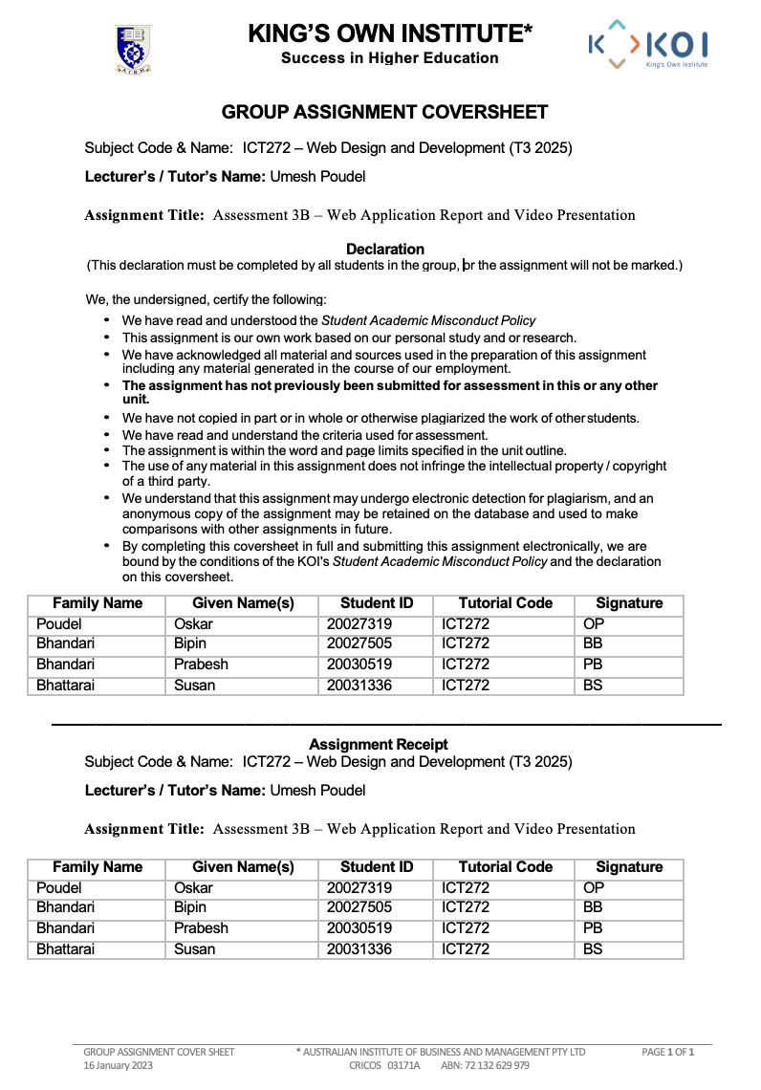

Table of Contents
1. Executive Summary 6
2. Introduction and Background 7
3. Functional Requirements and Benefits. 8
4. Entity Relationship Diagram (ERD) 10
5. Use Case Diagram 12
6. Security Analysis 14
7. Testing Strategy 16
8. Screenshot and detail of website 18
1. Public (Guest) Pages 18
2. Authentication Pages 25
3. Tourist (User) Pages 27
4. Admin Pages 33
5. Shared Layout Components 38
8. User Manual 39
Tourist User Guide 39
Admin User Guide 40
9. Literature Review 41
10. Conclusion 42
Bibliography 43
Project Resources 44

1. Executive Summary

The report is a design and development of a web-based Tourism Booking System that was built up on ASP.NET MVC and SQL express database. The system will ensure that the tourists have a secure, organised, and user-friendly system through which they can browse and book travel packages and travel agencies and tour guides have a good management system through which they manage tours, bookings and deal with their customers efficiently.

The system will provide tourists and administrators with secure user registration and user login, complete travel package and booking management, integrated feedback system and reporting to analyse the booking trends and packages popularity. Role-based access control is used to make sure that only authorised users are allowed administrative functions.

The application is developed based on the Model-View-Controller (MVC) architectural pattern, which decouples data management and business logic information in addition to the user interface. This will enhance maintainability, scalability and clarity of the system in general. Authentication, input validation, and sensitive user information protection measures have been implemented to improve the system reliability. Besides, the strategies such as unit testing, integration testing, user interface testing and security testing were also performed to ascertain the robustness and reliability of the web application.

2. Introduction and Background

The fast development of the online tourism platforms has raised the necessity of the secure, convenient and properly organized Web-applications. In most of the conventional tourism systems, tourists are usually confronted with challenges in seeking appropriate tours, executing reservations as well as monitoring booking conditions attributed to disjointed data and ineffective procedures. Simultaneously, travel agencies and tour guides face difficulties in organizing tour packages, details of the participants, bookings, and payment details. The problems may lead to inefficiency in operations and user dissatisfaction.

The Tourism Booking System was created in response to such problems that aim to gather all the tourism-oriented processes into one web-based program. By making it easier to search through tours, book tours, manage reservations, and analyse booking information, the system simplifies the process of travel management of both travel providers and tourists. The consolidation of these functions increases the level of transparency, decreases the administrative work representations, and also increases the overall user experience.

The application is created on the basis of ASP.NET MVC written in C# and SQL Express database management. This technology stack enables the ability to create dynamic, responsive and well-structured web pages and also supports a secure lateral, role-based access control, and the CRUD (Create, Read, Update, Delete) operations necessary to manage tour packages, bookings, and user feedback. Moreover, integrated reporting tools allow the administrators to review booking trends, participant data, and pricing performance and make better-informed decisions and enhance business performance. The project corresponds to the learning outcomes of ICT272 because it shows practical application of the principles of development of dynamic web applications, integration of databases, and professional design of the interface.

3. Functional Requirements and Benefits.

Functional Requirements
Authentication and Authorisation of the user.
The system supports both insecure and secure user registration, and login functions of tourists and administrators. Role based access control limits the administrative features to the authorised users alone to exclude sensitive data in the system.

Tour Package Management
Administrators are able to add, update and delete tour packages. The details of each tour consist of the title, description, price, pictures, tour dates, and the number of people allowed in the group. This enables those in charge to organize tour offerings effectively.

Booking Management
Tourists will be able to book tours with their personal information and number of participants. The system contains booking requests that are in the Pending status and which can be later changed to either Confirmed or Rejected by the administrators. The system allows the tourist to check their booking status and monitor it.

Feedback and Rating System
On completion of a tour, the tourists are able to provide their feedback and rating. This aspect enables travel providers to compare the quality of the services and make future offerings better.

Reporting and Monitoring
The system has the reporting features that enable the administrators to examine the trend of booking, popularity of the tour and the participant information.

Benefits of the System
- Facilitates the tour booking by the tourists through a centralised online system.
- Reduces the amount of work that the administration has to do by automating the booking and management of the tours.
- Improves transparency by showing real time booking of the tourism.
- Enhances the process of decision making through reporting and data analysis.
- Guarantees safe management of user information by authenticating and validating.

4. Entity Relationship Diagram (ERD)
The Entity Relationship Diagram (ERD) comprises the main body of data of the Tourism Booking System as it shows how the leading entities interact with each other within the system. The ERD is drawn out to help in the effective management of data, safeguard the data and represent the real-world scenario in tourism booking.

Core Entities
The main figures in the system are User, Tour, Booking, Feedback and Login Attempt.

Relationships
User - Booking (One-to-Many):
A single user (tourist) can place multiple reservations.
Tour - Booking (One-to-Many):
The tour can be reserved by different users.
User - Feedback (One-to-Many):
One is allowed to make various feedbacks regarding various tours.
Tour - Feedback (One-to-Many):
There can be various feedbacks on the same tour by various users.
User -Login Attempt (Many-to-Many):
A user has access to a number of login attempts being logged in to secure and monitor activities.

Entity Relationship Diagram (ERD)
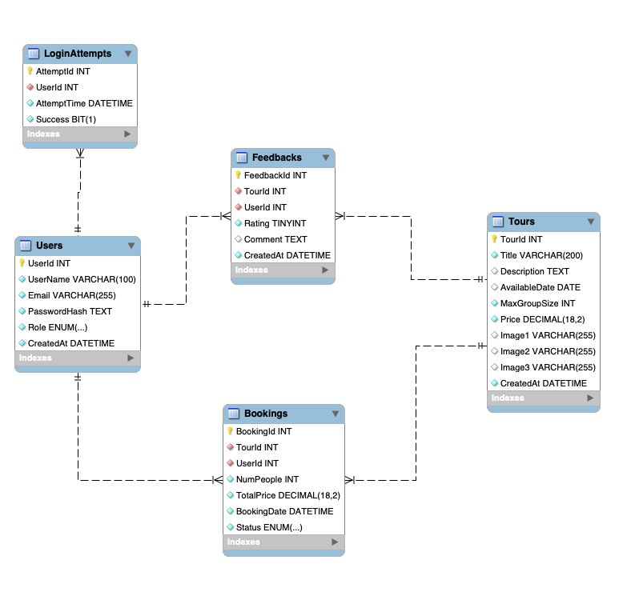
Justification of Architecture

The Model-View-Controller (MVC) architecture will be very appropriate to the Tourism Booking System since it divides the application into three distinct parts: Models, Views, and Controllers. This division enhances maintainability, future scalability, and division of responsibilities in the system.

MVC approach also can be integrated with more features like payment gateways or multi-currency suing at any point. SQL Express offers organized and trustworthy storage of tours, booking, and user data, whereas the ASP.NET MVC offers a secure authentication, input validation, and user interface design.

5. Use Case Diagram
The Use Case Diagram demonstrates the interaction of the Tourist and Admin with the Tourism Booking System and their key functions, along with the general system behaviour, whilst the processes of authentication and data handling are handled by the system.

Actors

Tourist/User
An end user who is a tourist is one that enters the system to view available tours and book the tours.

Role in the System:

- Views presented available tours, tour information.
- Books tours through the provision of personal information like name, email, phone number and actual participants.
- Check personal booking history including booking status (Pending, Confirmed or Rejected).
- Removes or cancels reservations as allowed by the computer system.

Admin

The admin is an administrator who manages tours, bookings and general management of the system.

Role in the System:

- Authorizes, modifies and removes tour packages, like the images, pricing, and description.
- Browses all the bookings done by tourists.
- Changing booking statuses (Pending, Confirmed, or Rejected)
- Booking of activities to make the systems run smoothly and efficiently.

System
The system is a collection of components used as the backend and handles data processing, authentication, and user-to-user synchronization.
Use case Diagram

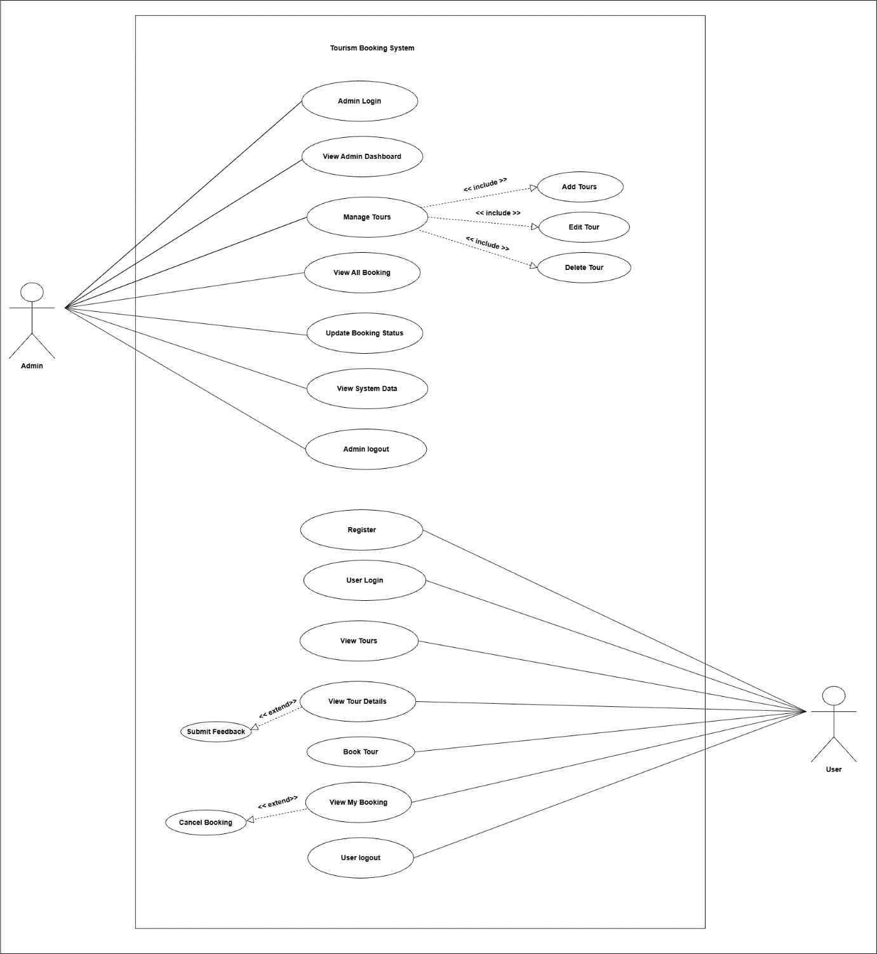

6. Security Analysis

The Tourism Booking System has a sensitive component of security since the application is dealing with personal data of its users, booking records, and logins. To adhere to best practices of web application development, the system was developed keeping in mind several security aspects to safeguard the confidentiality, integrity, and the availability of data.

Authentication and Authorisation of users.
The system uses secure authentication procedures that will ensure that system functionality is accessed by only authorised users. Tourists and administrators will be obliged to register and log in with valid credentials. Access control is implemented by role-based access control, where only the administrative users will have access to administrative privileges, including updating of the status of the booking and also the management of the tours. This will stop unauthorised entry to sensitive system activities.

Password Security
Plain text passwords are not stored. Rather, they are stored in the database in the form of a hash of the passwords. This will secure user credentials in case of an unauthorised access to the database, which will contain a minimal risk of a data leak.

Input Checking and Data Integrity.
The asp.net MVC framework is used to implement input validation through data annotations. This is to make sure that all the user inputs which are registration information, booking information and feedbacks are in the correct format and constraints. Input validation is useful in avoiding general security vulnerability like SQL injection, invalid data input and malicious input attacks.

Secrecy of Confidential Records.
The system also provides the security of sensitive user and booking data in SQL express database. This data is not accessed directly or unauthorised by the database by controlling access to its business logic layer. Also, there is record of the logins to facilitate monitoring and possible security audits.

Access Control and Session Management.
Session management makes sure that users are not authenticated unless it is active. Automatically, users are forced to re-authenticate upon logging out or a session lapse. This minimizes the chances of hijacking and unauthorised access of the session.

System Reliability and Monitoring.
Introduction of tracking of login attempts enhances the security of the system as administrators get a chance to trace abnormal login activities. This can be one of the upgrades that can be made in future to offer account lockout features or alerts in case of frequent failed logins.

7. Testing Strategy
To ensure that all the system components address the functional and non-functional requirements and offer a positive user experience, a combination of testing methods was used.

Unit Testing
Individual components of the application were tested using unit testing, especially controller actions and model logic. The functions were tested individually and included tour creation, placing a booking, and processing feedback, as well as other functions, to guarantee that they yielded the desired results. This assisted in discovering errors in logic at an earlier stage of the development.

Integration Testing
Integration testing was performed to ensure that various system components interacted with each other such as the ASP.NET MVC application and the SQL express database. This made sure that data would be properly stored, edited and retrieved between models, controllers and views. The factors of integration tests were established to ensure that the CRUD operations were going well in the system.

User Interface (UI) Testing
Test based on user interface was aimed at confirming that web pages were displayed properly and navigation was user-friendly. Forms, buttons, navigation menus and validation messages were also tested so as to be consistent and usable throughout the application. This testing was to determine that the tourist as well as the admin interfaces was intuitive and responsive.

User Acceptance Testing (UAT)
The point of view of the tourists and the administrators was carried out as part of the user acceptance testing. Tours were navigated, bookings were made, booking status was viewed and feedback was submitted by the tourists. Administrators also tried tour management, booking approval and system monitoring functions. UAT ensured that the system was as expected and functional.

Security Testing
Security testing was done to test authentication, role-based access control and input validation. This involved checking the functionality of logins, restriction of access to the pages of the administration, and the verification of the rules to prevent the usage of invalid or malicious input.

8. Screenshot and detail of website

1. Public (Guest) Pages
1.1 Home Page

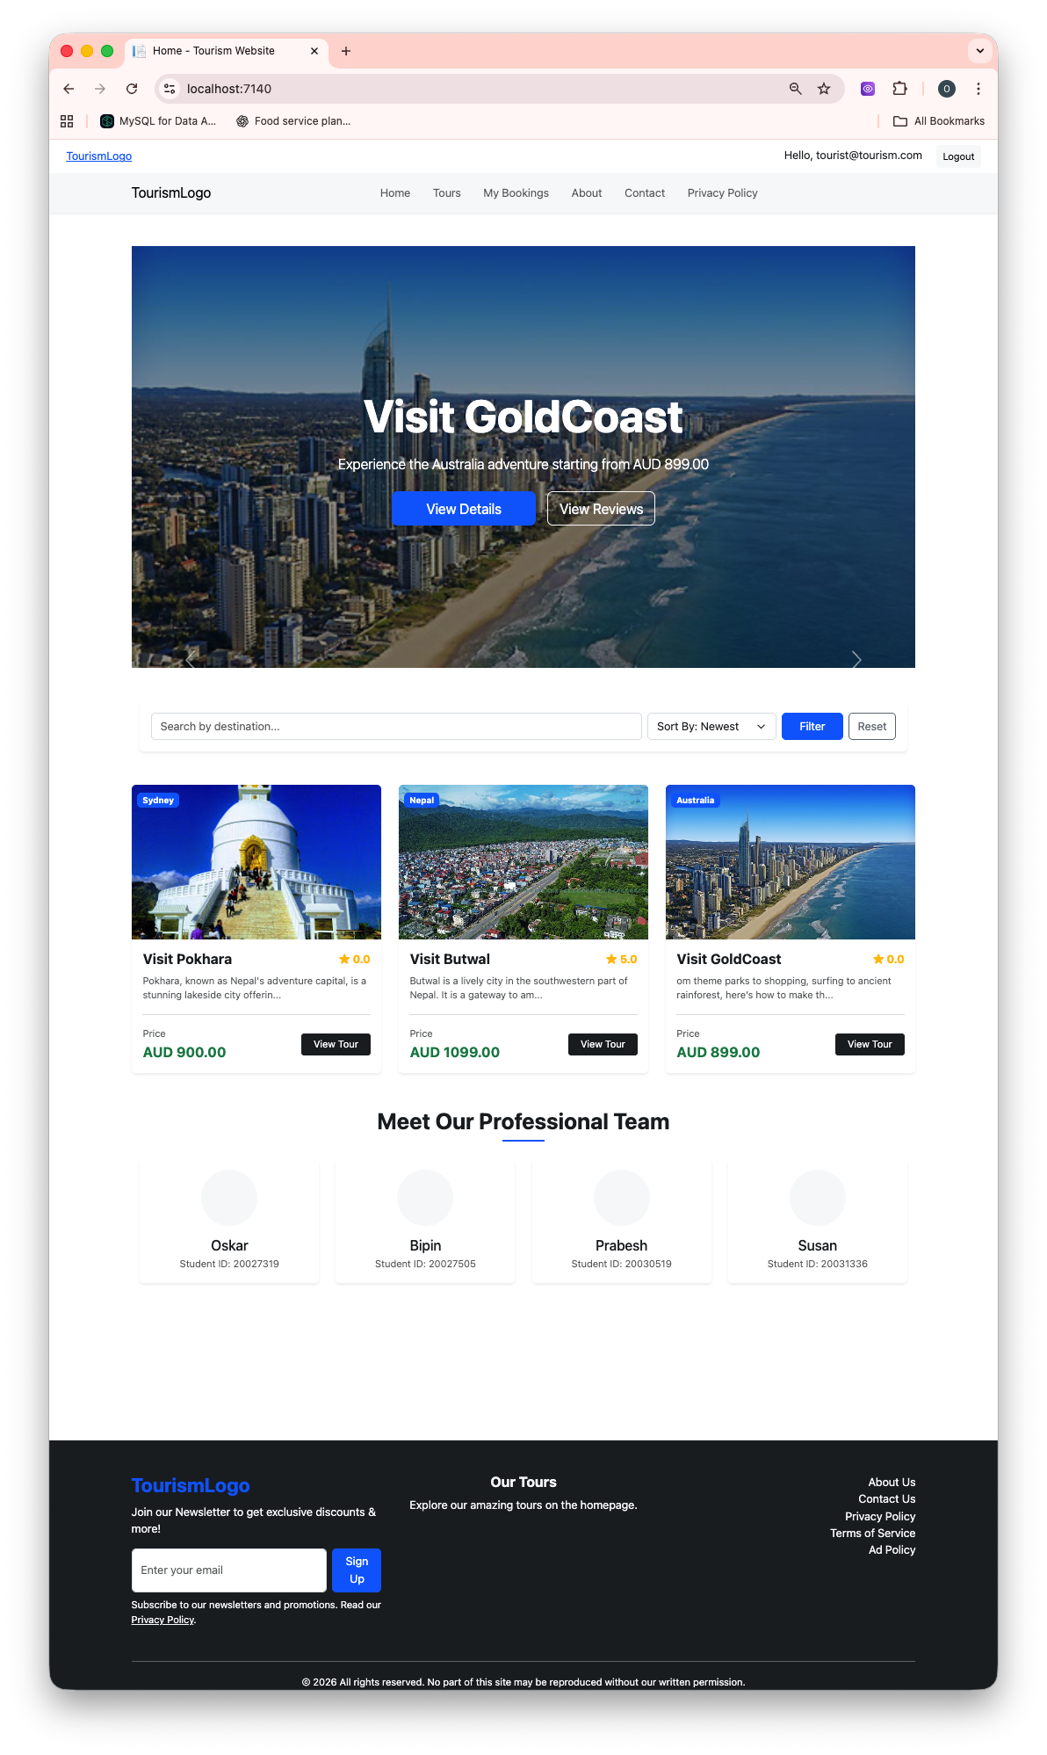
Figure 1:Home Page

Figure 1: Home Page
- System logo (Tourism Logo)
- Navigation bar
- Hero section with tourism images
- Search and featured tours

Purpose: To acts as the main entry point for all users.
1.2 About Us Page
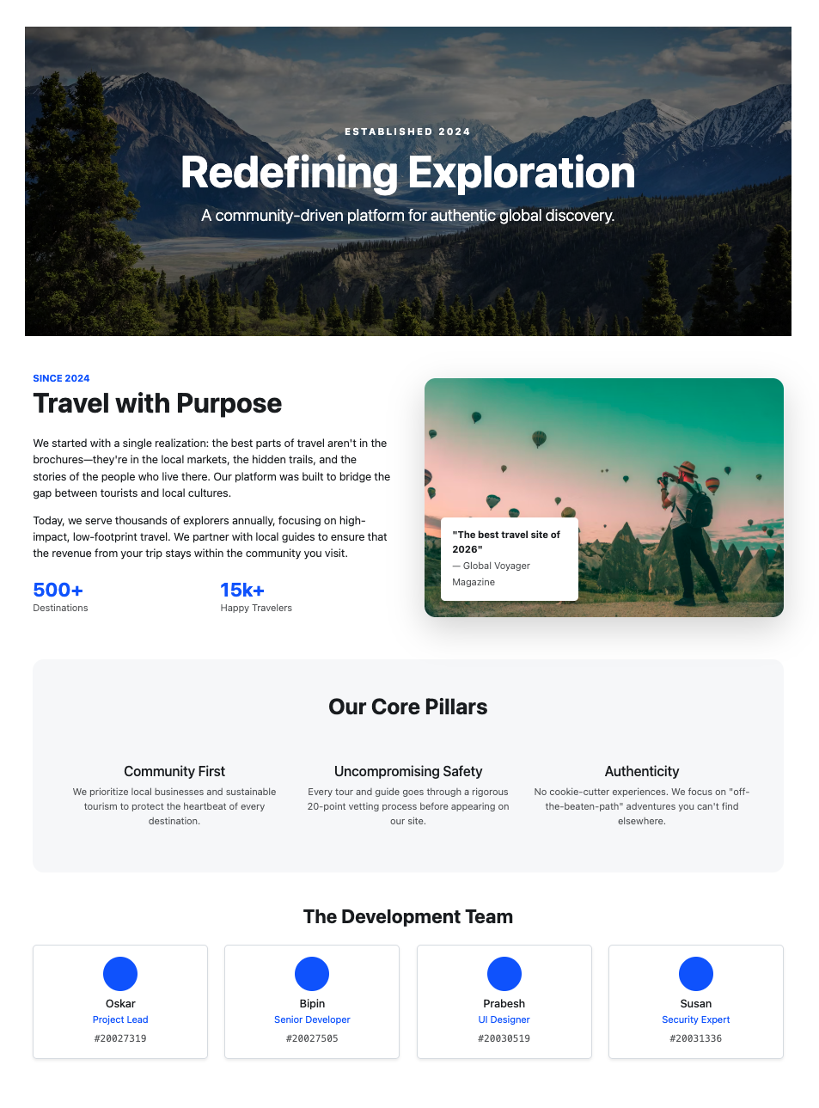
Figure 2: About Us Page
Figure 2: About Us Page
- Information about the tourism company/system
- Mission and objectives
Purpose: To builds credibility and user trust
1.3 Contact Us Page
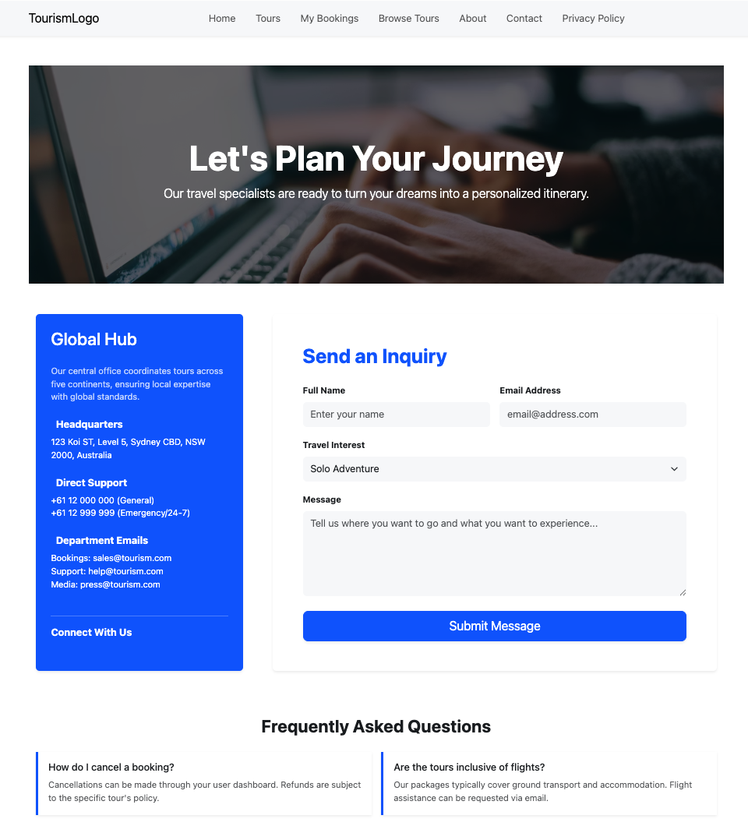
Figure 3: Contact Us Page
Figure 3: Contact Us Page
- Contact details and inquiry information

Purpose: This page allow users to communicate with administrators.

1.4 Privacy Policy Page
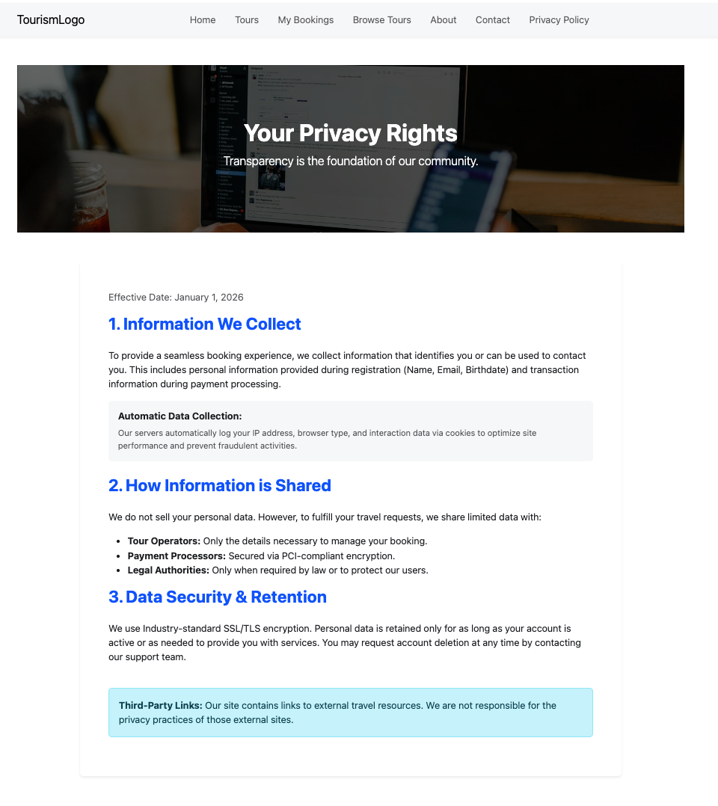
Figure 4: Privacy Policy Page
Figure 4: Privacy Policy Page
Explains data collection and privacy handling

Purpose: To ensures compliance with privacy standards.

1.5 Terms of Service Page
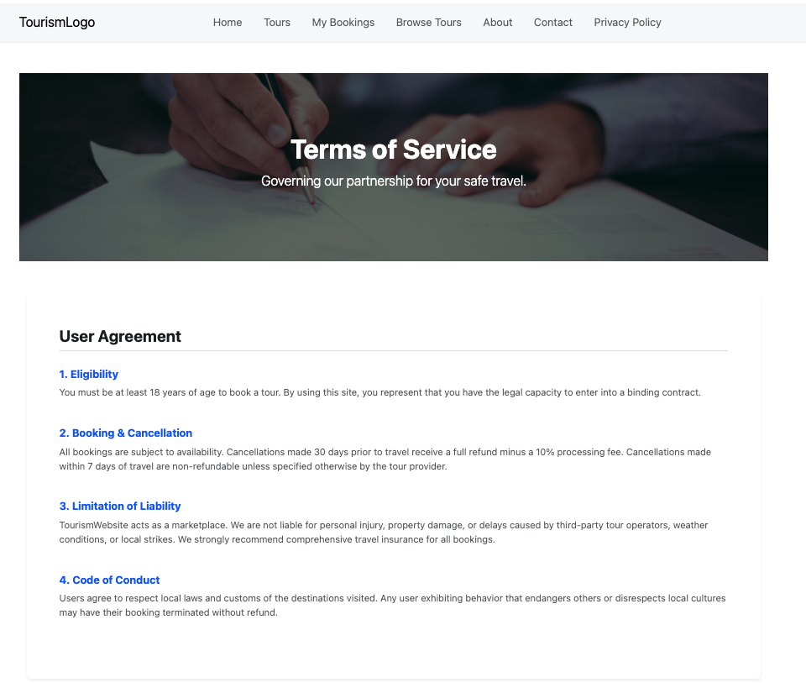
Figure 5: Terms of service page
Figure 5: Terms of Service Page
Rules and conditions for system usage

Purpose: To find out the legal responsibilities of users.

1.6 Advertisement Policy Page
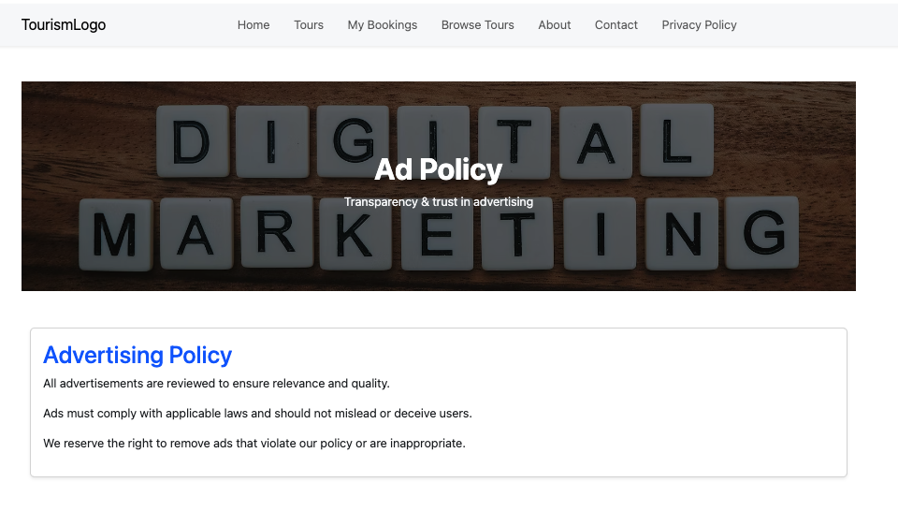
Figure 6: Advertisement Policy Page
Figure 6: Advertisement Policy Page
Advertisement rules and conditions

Purpose: To ensures ethical and transparent advertising.

2. Authentication Pages
2.1 Login Page
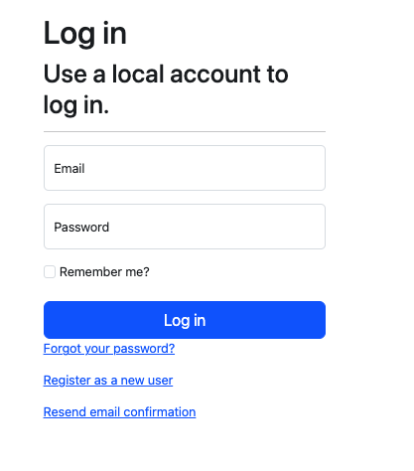
Figure 7: Login Page
Figure 7: Login Page
- Secure user login form
- Validation messages

Purpose: To authenticates registered users.

2.2 Registration Page
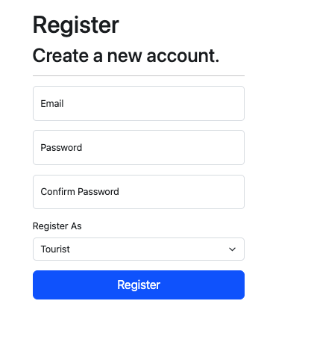
Figure 8: Registration Page
Figure 8: Registration Page
- User registration form
- Role assignment (Tourist)

Purpose: To allows new users to create accounts.

3. Tourist (User) Pages
3.1 Tours Page
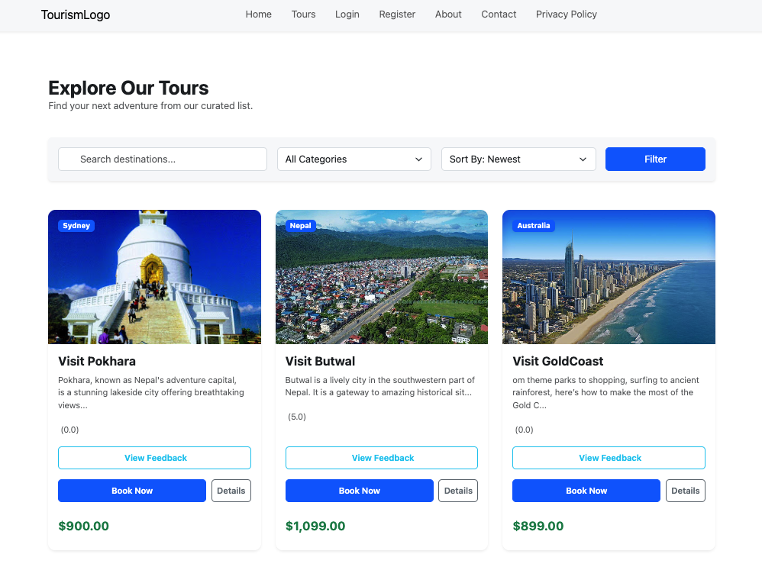
Figure 9: Tours Listing Page
Figure 9: Tours Listing Page
- Displays all available tours
- Tour cards with images and details

Purpose: Allows tourists to browse available tours.

3.2 Tour Details Page
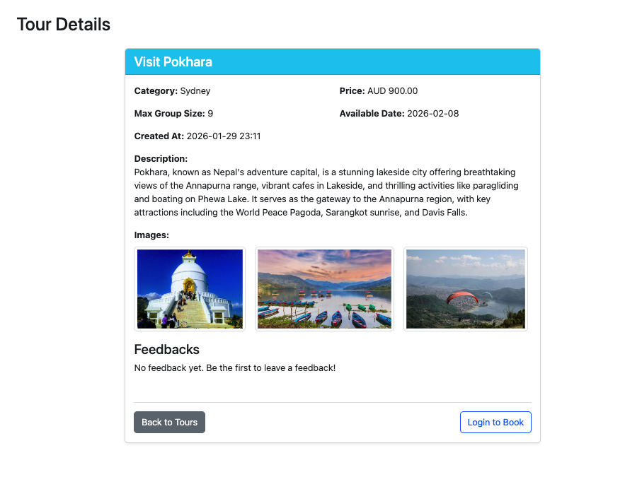
Figure 10: Tour detail Page
Figure 10: Tour Details Page
- Detailed tour information
- Booking and feedback options

Purpose: To guide tourists make informed decisions.

3.3 Booking Page
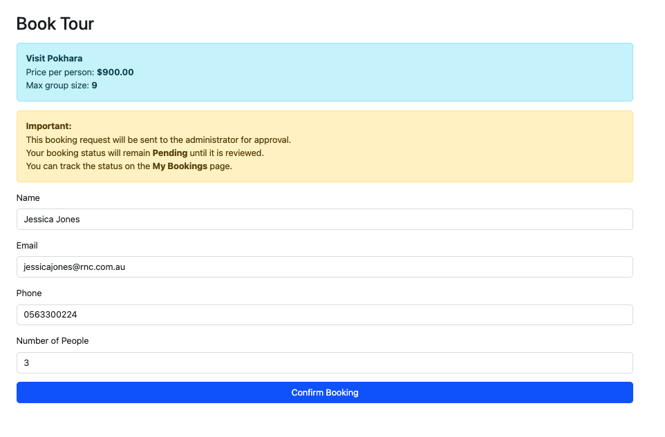
Figure 11: Tour Booking Page
Figure 11: Tour Booking Page
- Booking request form
- Status set to Pending

Purpose: It allows tourists to request tour bookings.

3.4 My Bookings Page
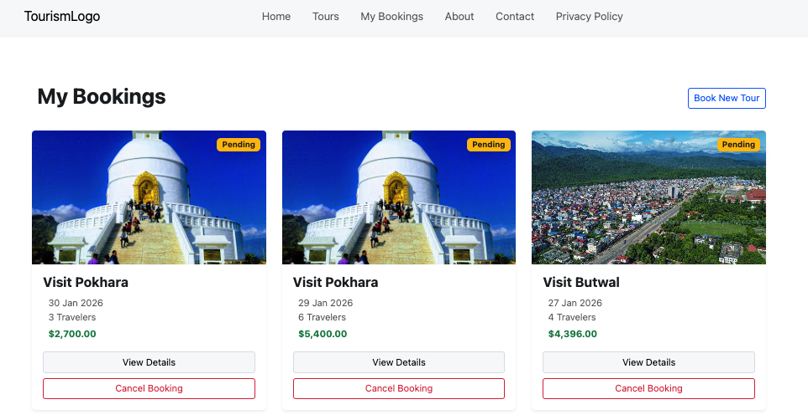
Figure 12:My booking Page
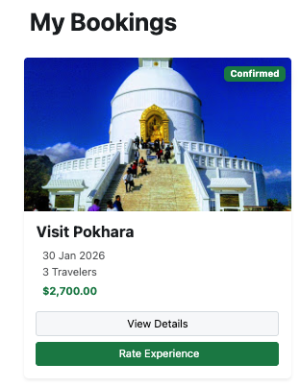
Figure 12: My Bookings Page
- Displays tourist’s bookings
- Booking status (Pending / Approved / Rejected)

Purpose: It allows tourists to track booking status.
3.5 Feedback Submission Page
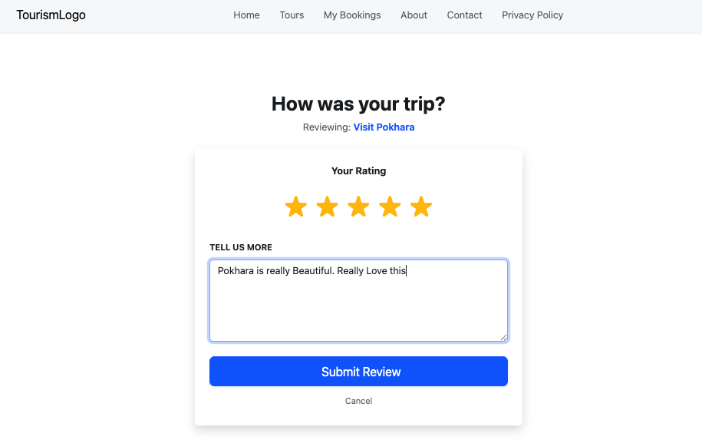
Figure 13: Feedback Submission Page
Figure 13: Feedback Submission Page
- Star rating system
- Comment submission

Purpose: Collects user feedback.

3.6 Feedback Display Page
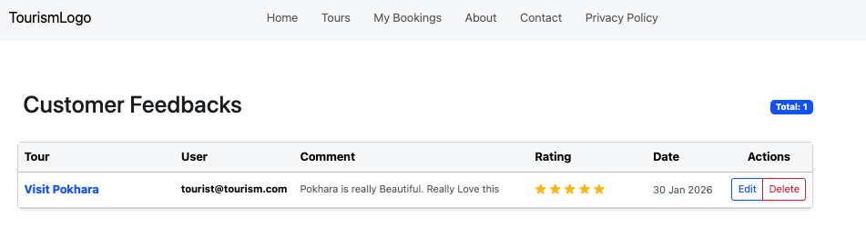
Figure 14: Feedback Display Page
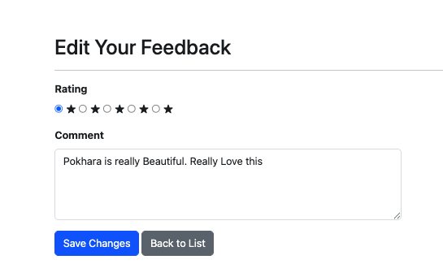
Figure 14: Feedback List Page
- Displays feedback for each tour
- Show’s ratings and comments

Purpose: To find out Improves transparency and service quality.

4. Admin Pages
4.1 Admin Dashboard

Figure 15: Admin Dashboard

Figure 15: Admin Dashboard
- Overview of system activities
- Quick access to management features

Purpose: Central control panel for administrators.

4.2 Manage Tours Page
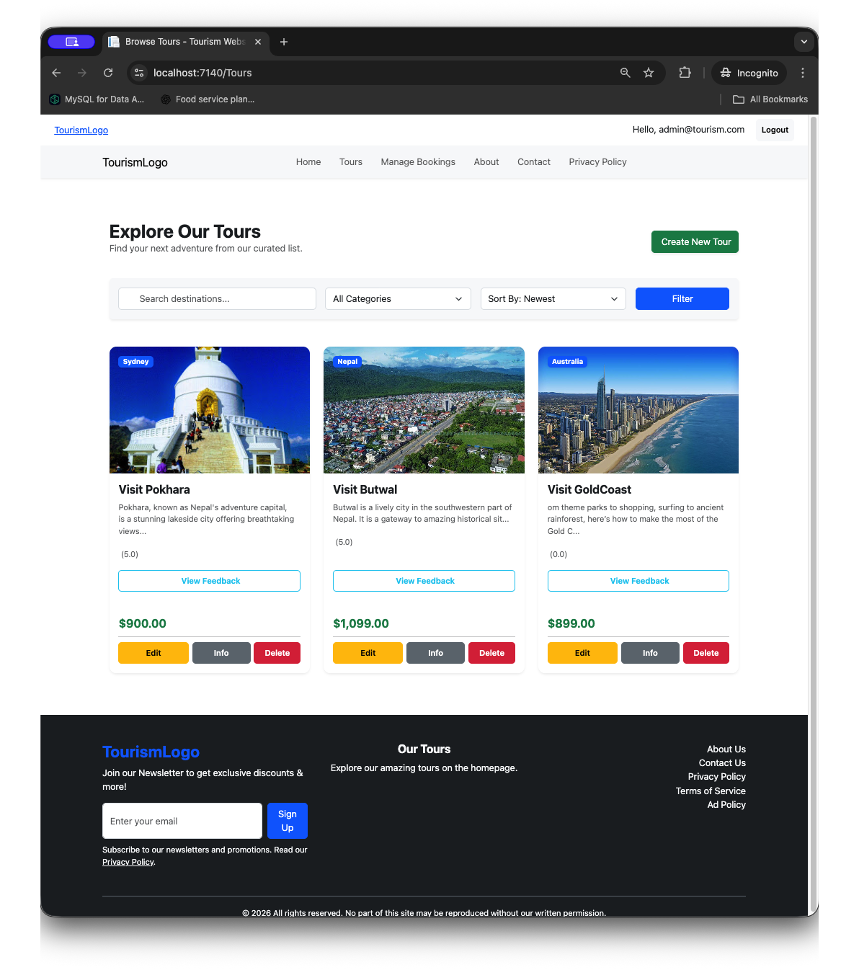
Figure 16: Manage tour Page
Figure 16: Manage Tours Page
- Add new tours
- Edit existing tours
- Delete tours

Purpose: It allows administrators to manage tours.

4.3 Add / Edit Tour Page
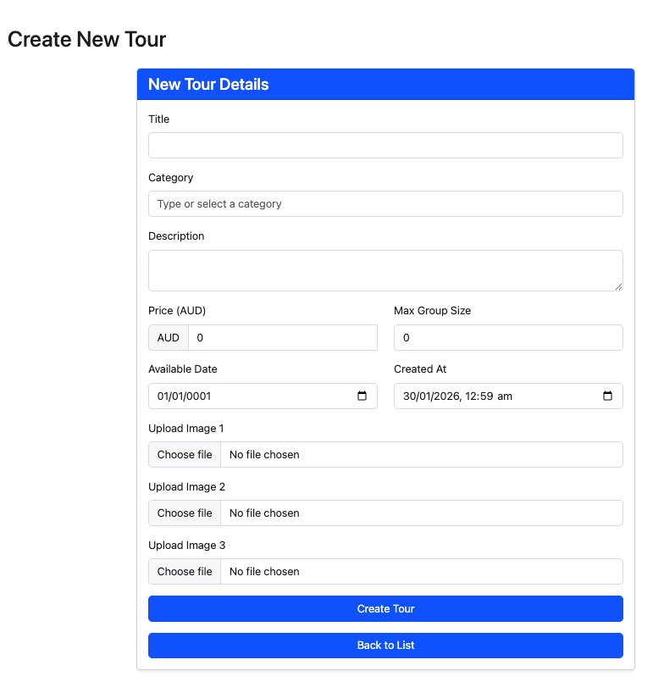
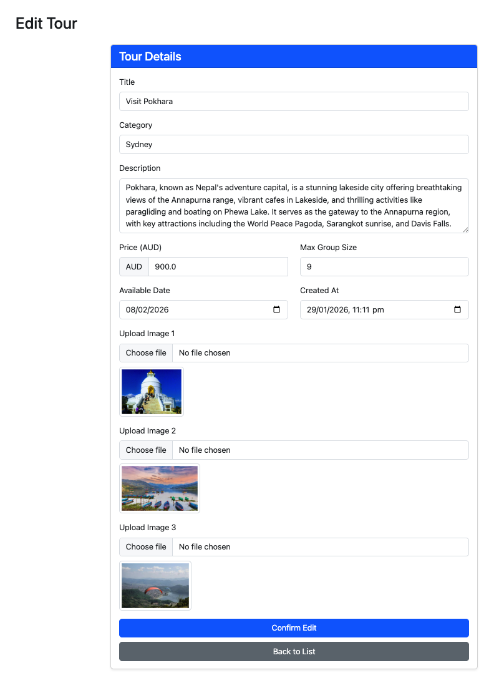

Figure 17: Add/Edit Tour Page

Figure 17: Add/Edit Tour Page
Form for tour details (title, description, price, image, group size)

Purpose: To enables tour creation and modification.

4.4 Manage Bookings Page
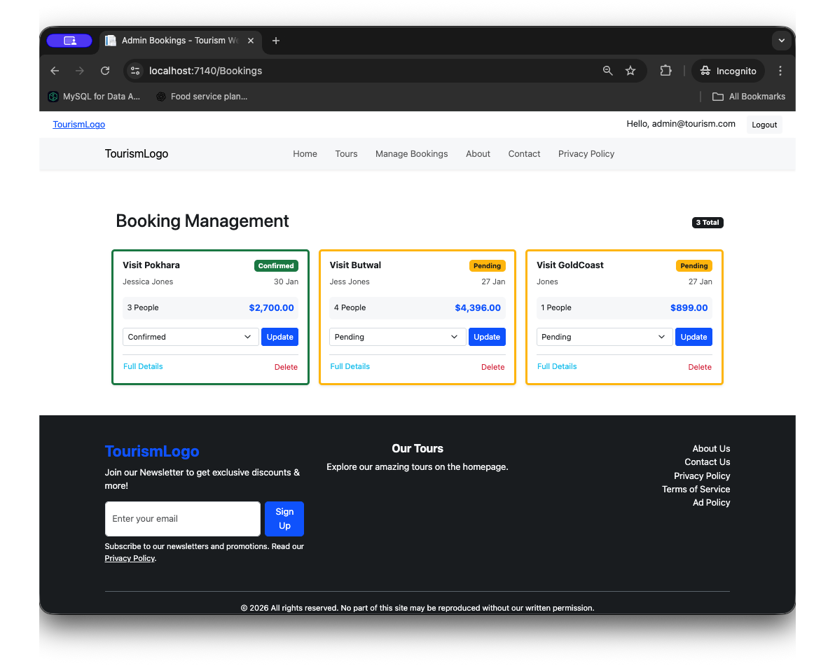
Figure 18: Manage Bookings Page

Figure 18: Manage Bookings Page
- View all booking requests
- Approve or reject bookings
Purpose: It allows administrators to control tour capacity.

4.5 Manage Feedback Page
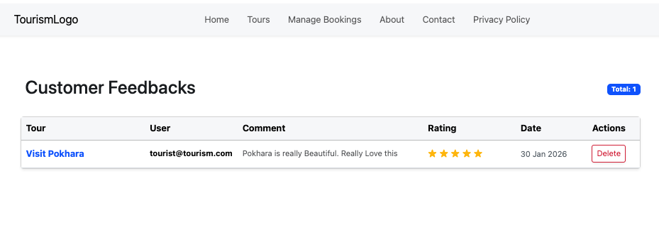
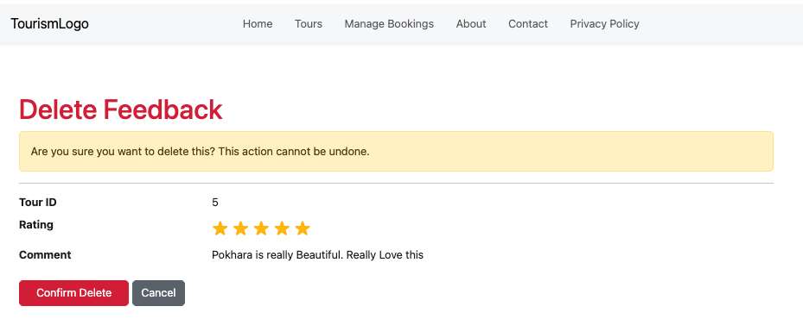
Figure 19:Manage Feedback Page

Figure 19: Manage Feedback Page
- View submitted feedback
- Delete inappropriate feedback if required

Purpose: It allows to maintains quality and moderation.

5. Shared Layout Components
5.1 Navigation Bar

Figure 20: Navigation Bar

Figure 20: Navigation Bar
- Role-based menu items (Tourist/Admin)

Purpose: To allows users to quickly access relevant pages

5.2-Footer Section
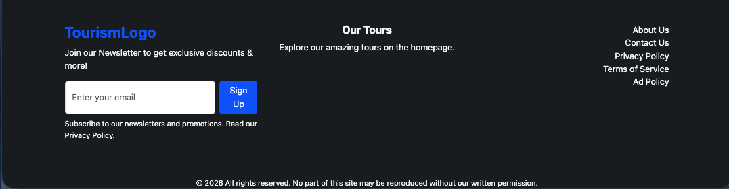
Figure 21: Footer Section
Figure 21: Footer Section
- Quick links
- Social media icons
- Copyright information

Purpose: To Displays essential information and quick links

8. User Manual
This section presents a walk through on how to use the Tourism Booking System. The system will be easy to use and can be accessed by both the tourists and administrators.

Tourist User Guide

Registration and Login
- New users will be registered by typing their name, email and password.
- Using their credential’s, registered users are able to log in.

Browse Tours
- Visitors will be able to see the tours that are offered in the Tours page.
- Each tour has information about its description, cost, photos, and dates.

Book a Tour
- The tourists can choose a tour and send a request to book it by entering the number of the participants and their contacts.
- The status of booking will be Pending.

View My Bookings
- All of the bookings can be viewed by the tourists in the section My Bookings.
- Statuses of booking are automatically revised at approval or rejection by the admin.

Submit Feedback
- Tourists may post a rating and their feedback after visiting a tour.

Admin User Guide

Admin Login
- To access the administrator, administrators use the admin credentials.

Manage Tours
- Admins are able to add new tours, modify the existing tours or delete tours.
- The tour specifications consist of the title, description, price, and images, and the size of the group.

Manage Bookings
- In a table format, admins can see all the booking requests.
- Status of booking may be changed to either Pending, Confirmed or Rejected.

Monitor System Activity
- The admins will be able to see the booking patterns, tourist data, and feedback to maintain the proper functioning of the system.

9. Literature Review

The literature review helps to justify the testing and development strategies of the experiment with the Tourism Booking System with references to the accepted research and industry best practices. Research concerning web application development emphasises that Model-View-Controller (MVC) architectures enhance maintainability, scalability and decoupling. The ASP.NET MVC has become a popular application in industry because of its organised nature of development, in-built back-off systems and ability to integrate with relational databases.

Literature on software engineering has highlighted the need to use a variety of testing methods in order to guarantee quality and reliability of the system. Unit testing is also usually employed to identify component level errors whereas integration testing is employed to identify proper interaction of modules of a system. The user acceptance test is necessary to ensure that the system addresses the requirements of the user and provides a good user experience. Security testing is also imperative to secure sensitive user information and to avoid unauthorised access of such information.

According to usability studies, understandable navigation, responsive designs and unified user interface layouts are important factors that increase user satisfaction. The principles were implemented in the Tourism Booking System to make it easy to use by tourists as well as administrators. All in all, the literature supports the development and testing methods used in the current project and justifies the applicability of ASP.NET MVC in the development of secure, scalable, and user-friendly web applications.

10. Conclusion

The Tourism Booking System is able to achieve the aims of this assessment since it provides a secure, organised, and easy-to-use web application to run tourism-related activities. The system is developed on the ASP.NET MVC and SQL Express database to provide a powerful platform that would enable tourists to explore and book tours and enable administrators to easily handle the tour packages, bookings and interactions between users.

The system is developed as per the Model-View-Controller (MVC) architecture that guarantees the separation in data, business logic and user interface elements. Such basic aspects as user authentication, role-based access control, booking control, feedback collection, and reporting represent the real-life needs in tourism management. The ERD and use case design also facilitate the creation of a structured and scalable system architecture.

The security and reliability were considered by the implementation of authentication, password hashing, input validation, session management, and monitoring of the login attempts. The most important aspects that were employed to ensure the robustness and usability of the system were inclusive testing plans, including unit testing, integration testing, user interface testing, user acceptance testing, and security testing. Overall, it can be concluded that the project is an excellent illustration of how the principles of web development, database design, and security that I learned throughout the ICT272 course can be successfully applied and used as a ground to upgrade the system in the future.

Bibliography
Booking.com. (2025). Online travel and accommodation booking platform.
https://www.booking.com
Microsoft. (2025). ASP.NET Core MVC documentation.
https://learn.microsoft.com/aspnet/core
Microsoft. (2025). ASP.NET Core Identity: Authentication and authorization.
https://learn.microsoft.com/aspnet/core/security/authentication/identity
Microsoft. (2025). Entity Framework Core documentation.
https://learn.microsoft.com/ef/core
Bootstrap. (2025). Bootstrap 5 documentation.
https://getbootstrap.com
SQLite. (2025). SQLite database engine.
https://www.sqlite.org
OWASP. (2024). OWASP Top 10 Web Application Security Risks.
https://owasp.org/www-project-top-ten/
d

Project Resources
Bipin, Oscar, Prabesh, & Susan. (2025).
Tourism booking web application – Source code repository.
GitHub repository:
https://github.com/oscarp10/ICT-272-Final-Website.git

Oscar, Bipin Prabesh, & Susan. (2025).
Tourism booking web application – Project documentation and assets.
Google Drive folder:
https://drive.google.com/drive/folders/1Vy9rofKaqQNY2O43r0nlkDybEnvauZbT?usp=drive_link

